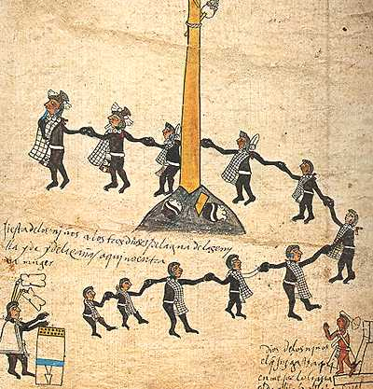
Children
Children are blessings to the parents.
They are source of joy to the community.
They are communally owned such that everybody should take care of the children.
They are supposed to be protected by all members of the community.
They are seen as the wealth of a society.

They like being together while carrying out various activities.
They value unity among themselves as they interact.
They interact freely because they do not have grudge with each other.
They are good example to the adults because they do hate each other.
They like enjoying themselves during leisure time.

They take part in certain festivals in the society such as commemoration of certain events.
They entertain people during the ceremonies through use of dances.
They put on costumes when entertaining audience in a festival.
They using musical instruments that accompany the songs.
They have a leader who guides them during the entertainment.

